EXP 02 – P.Malreddy (192372015)
Design a user interface prototype for a mobile station using Figma, considering connectivity and convenience.

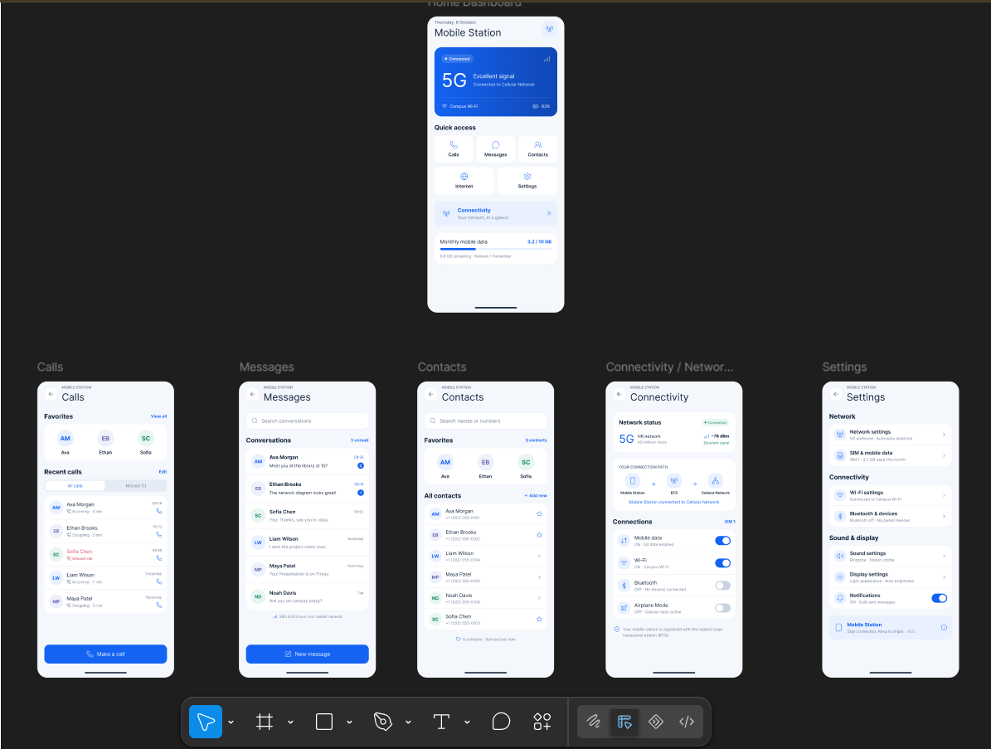

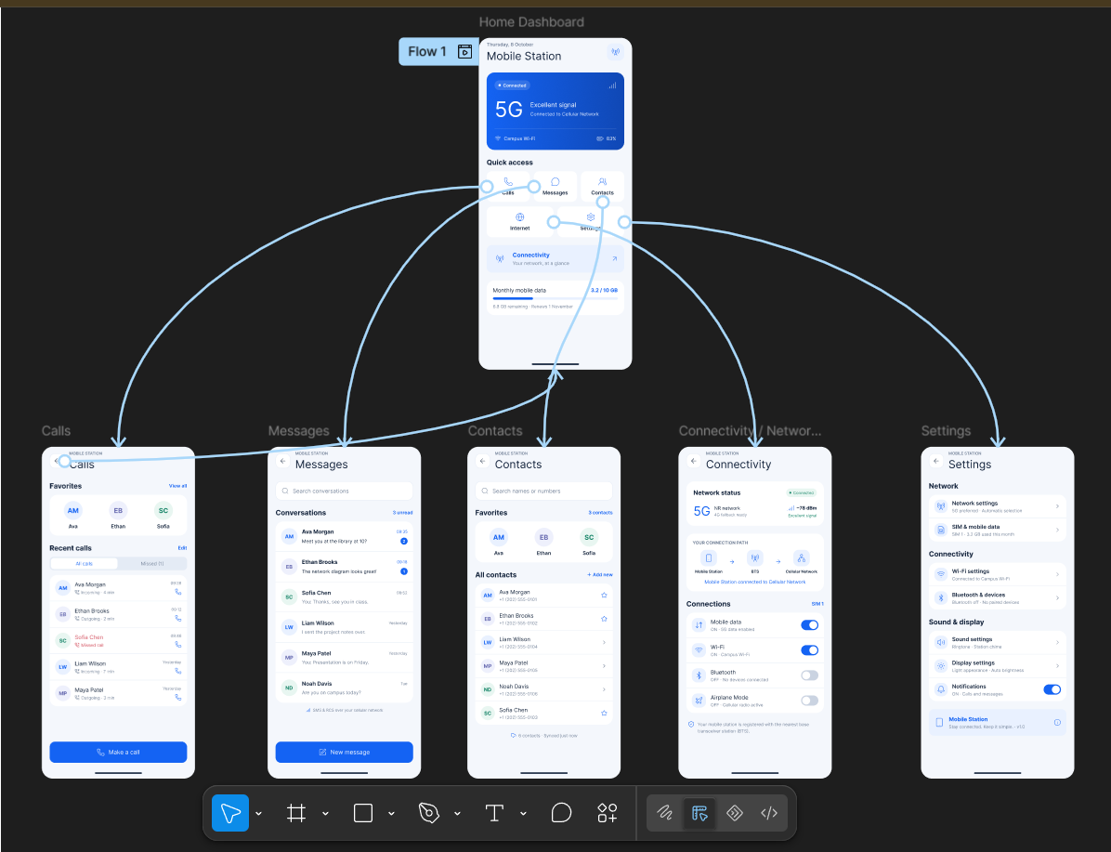

https://www.figma.com/design/bRCAU63yIJBH2s03TRfNxv/EXP-01-MC?node-id=1-2&t=Amd6ZmnRIRUXmm1W-0

